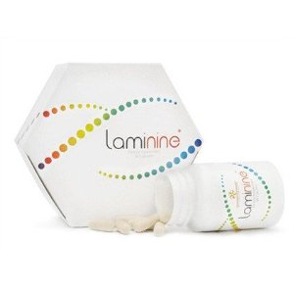
Raise Your Serotonin Levels & Promote Better Health Beginning at the Cellular Level!

Laminine (YTE) is clinically proven to raise your Serotonin (making you happier & calmer). It also lowers your Cortisol (the stress hormone) but is egg-based, NOT pharmaceutical!

LAMININE provides the most essential proteins and amino acids our body needs, along with the proper transport mechanisms to direct these nutritional building blocks to where our body needs it the most.
Whether it is a physical or mental challenge you face or just the need to handle everyday demands, Laminine may help.
Benefits may include:
- Improve Energy & Stamina
- Reduce Stress & Depression
- Promote More Restful Sleep
- Faster Recovery after Training
- Elevate Serotonin Levels
- Better muscle Tone / Strength
- Decrease Pain
- Reduce Signs of Aging
- Increase Clarity and Alertness
- Memory Enhancements
- Mood Enhancement
- Increase Libido & Burn Fat
- Aids in Brain Function

It’s no wonder we have had so many positive reports from Laminine users that are suffering from Alzheimer’s syndrome and ADD/ADHD.

The product referred to has not been evaluated by the FDA. The statements are not intended to diagnose, treat, cure or prevent any disease or condition. If you have a health condition or concern, consult a physician.


Laminine Contains:
A Natural, Synergistic Super Food
that contains 22 amino acids, trace
minerals, vitamins and Fibroblast
Growth Factor (FGF).

What is FGF?
Laminine was recently shown to burst fat cells when combined with exercise; and a large body of research shows that it helps rebuild brain cells and improves how neurons talk to each other. FGF also acts as a director for the full array of amino acids found in Laminine which are the building blocks of every function of your body.

Contact me for more information:

LifePharm Global Independent distributor
11 Clinical tests show Laminine’s POSITIVE effects on Physical, Mental & Emotional Health.

